Plant Watering Kit for Arduino UNO R4 WiFi Manual

SKU: KZ-0069

Introduction
Welcome to the Plant Watering Kit for Arduino UNO R4 WiFi, an all-in-one solution for enthusiasts and makers looking to delve into the world of smart gardening and IoT projects. This kit is designed to provide a hands-on experience with a range of electronic components and sensors, enabling you to create a fully automated plant watering system.
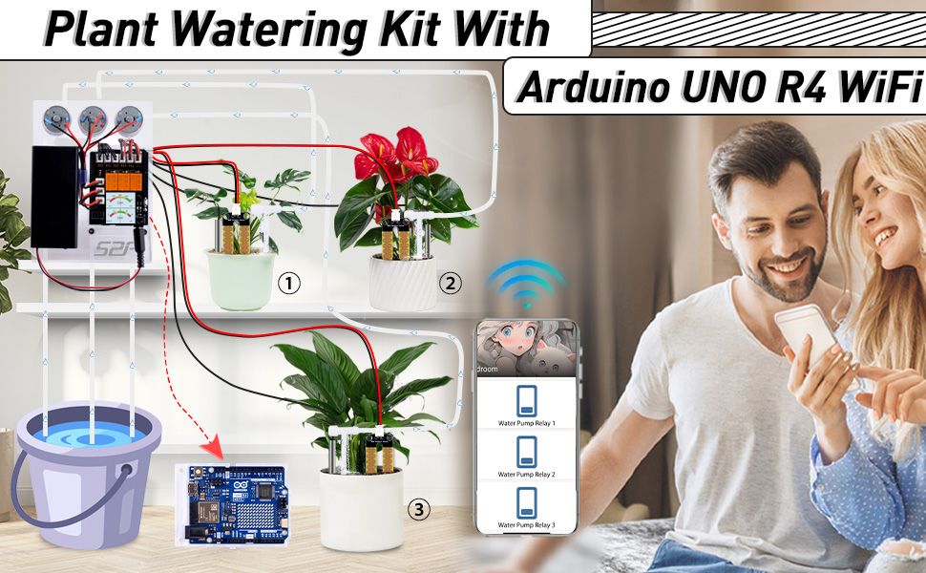

Contents
- Arduino UNO R4 WiFi
- Custom Arduino HAT Expansion Board
- LED Lights
- Soil Moisture Sensor Interface
- NTC Thermometer Interface
- 3-Channel Relay Module
- 1.3-inch TFT Color Display
- Onboard Infrared Receiver
- ESP01S Interface Socket
- 3 Soil Moisture Sensors
- 3 Water Pump Motors
- 18650 Battery Box
- Acrylic Stand
- Infrared Remote Control
- Online Documentation
- USB Flash Drive with Essential Resources
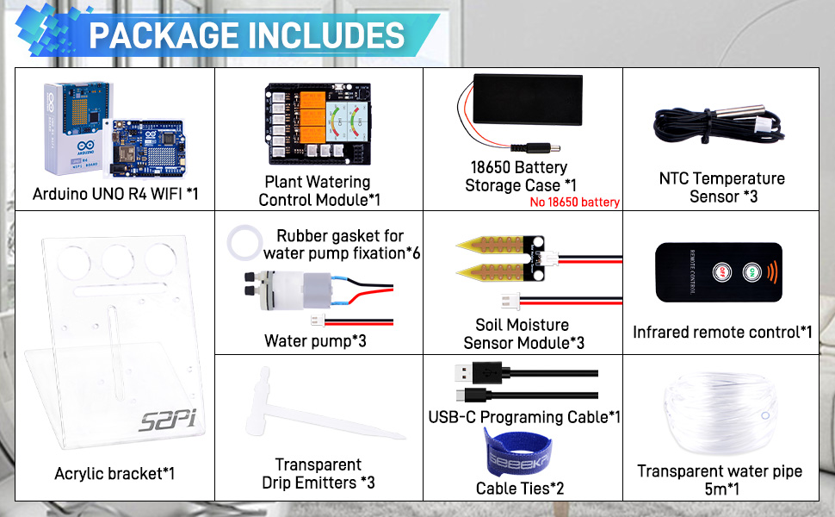

Features
- Arduino UNO R4 WiFi: The core of your project, featuring WiFi capabilities for IoT integration.
- Custom Arduino HAT Expansion Board: Enhances the UNO with additional functionalities such as LED indicators, sensor interfaces, and a relay module.
- Sensors and Modules: Equip your project with the ability to monitor and react to environmental conditions with soil moisture sensors, a temperature sensor, and water pumps.
- 1.3-inch TFT Color Display: Visualize data and control interfaces with a vibrant color screen.
- Infrared Receiver and Remote Control: Manage your system wirelessly with an infrared remote for added convenience.
- 18650 Battery Box: Optional power supply for portable projects.
- Acrylic Stand: A stylish and sturdy support for your setup.
- Comprehensive Documentation and Resources: Get started quickly with online guides and essential files on a USB flash drive.
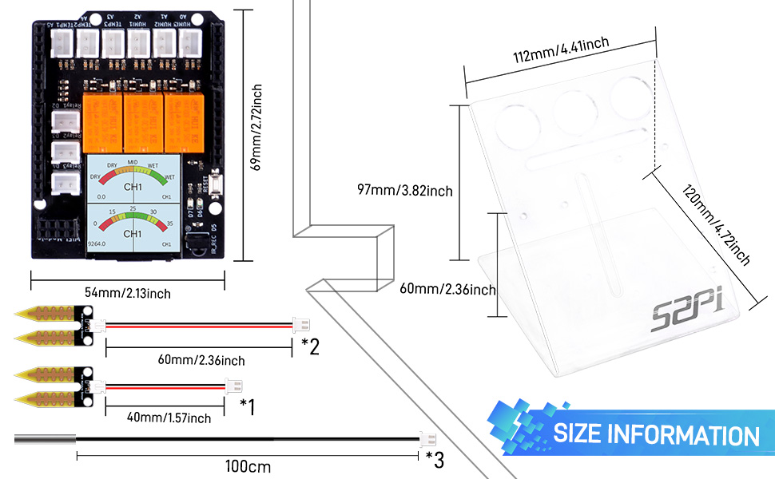

Application Scenarios
- Smart Gardening: Automate the watering of your plants based on soil moisture levels.
- Educational Purposes: Learn the basics of Arduino programming and electronics.
- IoT Projects: Integrate your project with platforms like Home Assistant for home automation.
- Data Visualization: Display real-time data on the TFT screen for monitoring temperature and humidity.
- Remote Control: Operate relays and pumps remotely using the infrared remote control.
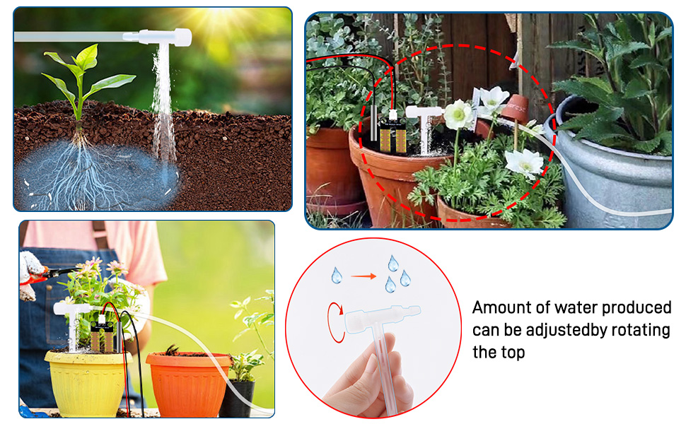
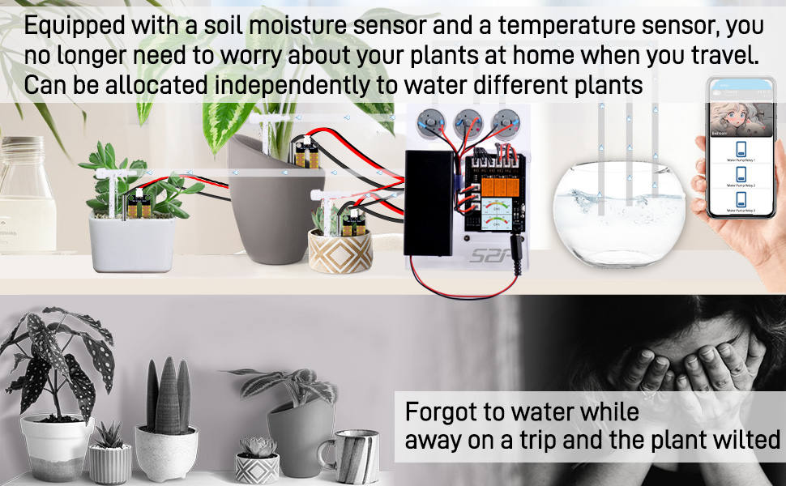

Getting Started
- Assemble the components according to the provided diagrams.
- Follow the online documentation to program the Arduino UNO R4 WiFi.
- Connect sensors and motors to the HAT expansion board.
- Write code to read sensor data and control the relays for water pumps.
- Integrate with IoT platforms using the WiFi module and MQTT protocol.

Easy to assemble

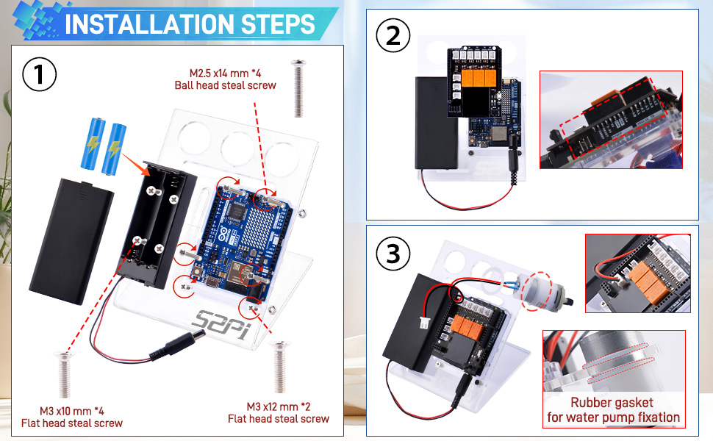

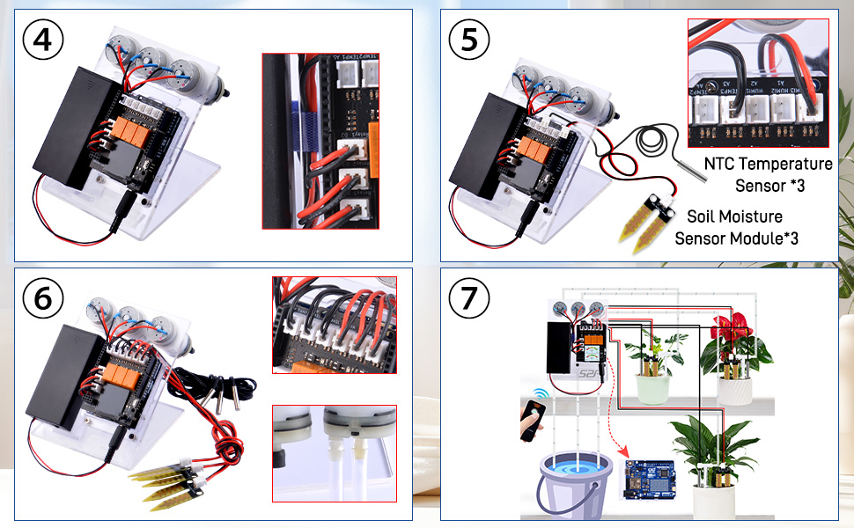

Support and Resources
For further assistance, refer to the online documentation or contact our support team. Join our community of makers to share your projects and learn from others.
Online Documentation: https://docs.52pi.com/md/kz-0069/package_includes/
or USB Flash Card with package.
This manual provides a basic framework and can be expanded with more detailed instructions, diagrams, and troubleshooting tips as needed.

